Name______________________________________Class_____Date_________
QUIZ GRADE
ECONOMICS STUDY GUIDE Chapter 1:What is Economics?
Lesson 1, pages 6-12 VOCABULARY
1._______________________________ fundamental economic problem faced by all societies resulting from a combination of scarce resources and people’s seemingly unlimited wants and need.
2. ______________________________Social science dealing with how people satisfy seemingly unlimited and competing wants and needs through the use of scarce resources
3. ______________________________A basic requirement for survival
4. ______________________________ Something we would like to have but isn’t necessary for survival.
5. ______________________________A useful, tangible economic product that is also transferable to others and used to satisfy wants and needs.
6. ______________________________An item that lasts at least 3 years with continual use
7. ______________________________An item that lasts less than three years with continual use
8. ______________________________An economic product intended for final use by consumers
9. ______________________________Tools, machinery, equipment, or other manufactured items used by businesses to create goods and services.
10. ______________________________Work or labor performed for someone.
11. ______________________________Worth that can be expressed in dollars and cents, like on a price tag.
12. ______________________________________The contradiction that occurs when necessities, such as water, command a lower price than non-necessities, such as diamonds.
13. _______________________________The capacity to be useful and provide satisfaction.
14. ______________________________The accumulation of products that are tangible, scarce, have utility and are transferable from one person to another.
15. ____________________________________________ -Also called ________________: The monetary (dollars and cents) value of all final goods, services and structures produced within a country’s borders in a 12 month time period.
Chapter 1-Lesson 2, pages 14-20 VOCABULARY
- _____________________________________ Productive resources needed to produce goods; the four factors are land, labor, capital, and entrepreneurship.
17. _____________________________________Refers to the “gifts of nature” or natural resources not created by people.
*18._____________________________________The tools, equipment, machinery and factories used by businesses to create goods and services
*19. _____________________________________The money, loans, credit that are used by businesses to purchase capital goods and create goods and services
20. _____________________________________People with all their efforts, skills and abilities. Sometimes called human capital. (Does not include entrepreneurs)

21. _____________________________________Risk-takers in search of profits who use existing resources to create new products or start businesses
22. _____________________________________A graph used by economists to illustrate all possible combinations of output of goods and services that can be produced if all productive resources are fully employed.
23. _____________________________________The value of the next best alternative that is given up when a choice is made.
24. _____________________________________ All of the alternatives that are given up when a choice is made
25. _____________________________________A social movement that began in the 1960s that was aimed at promoting the rights and interests of consumers
Chapter 1 – Lesson 3, pages 21-29 VOCABULARY
26. _____________________________________A nation’s total output of goods and services increase over time.
27. _____________________________________A measure of the amount of goods and services produced with a given amount of resources in a certain time period.
28. _____________________________________The sum of people’s skills, abilities, health, knowledge and motivation. (Like the term labor, but more)
29. _____________________________________Organizing a job into parts and having each worker or group complete one part of the whole job. (Think Henry Ford’s assembly line)
30. _____________________________________Giving each worker, work team or factory the specific job or jobs that they are best at or can do more efficiently. Becoming an expert in one job.
31. _____________________________________We rely on each other to produce the goods and services we all need.
32. _____________________________________Meeting place or other mechanism through which buyers and sellers meet to exchange economic products. Can be local, regional, national, global or in cyberspace.
*33. _____________________________________Process by which something can be accomplished.
34. _____________________________________Location where productive resources (the factors of production) are bought and sold.
35. _____________________________________Markets where producers sell their goods and services to consumers
36. _____________________________________ A simplified equation, graph or figure that explains how something works.
37. _____________________________________A way of comparing the benefits of an action to the expected costs
38. _____________________________________A market economy in which privately owned businesses, rather than the government, have the freedom to make the WHAT, HOW, and FOR WHOM decisions for themselves.
39. _____________________________________Our quality of life based on the possession of the necessities and luxuries that make life comfortable and easier

- Study Guide Questions
Chapter 1: Lesson 1
- Why do all societies face the problem of scarcity?

- Explain how needs and wants are different and how they are the same

- What’s the difference between a good and a service?

- Why are some necessities valued less than some non-necessities? Give examples in your explanation

- Connect the following: Adam Smith, Wealth of Nations, value and paradox of value

- Explain Adam Smith’s opinion on where a nation’s wealth really comes from.

- What are the 3 basic choices (3 economic questions) faced by every society?

- Why must choices be made?
- What is wealth made up of? Why are services not included in wealth?

- Why do we study economics?

Lesson 2
- What are the four factors of production? Describe each one

- Why must producers make choices about production?

- What would happen if one of the factors of production were missing?

- How does a production possibilities curve illustrate the decisions made in an economy?

- What is the difference between a trade-off and an opportunity cost?

- Why is it important to evaluate trade-offs and opportunity costs when making choices

- Study the production possibilities curve below and complete the activity in the box to the right
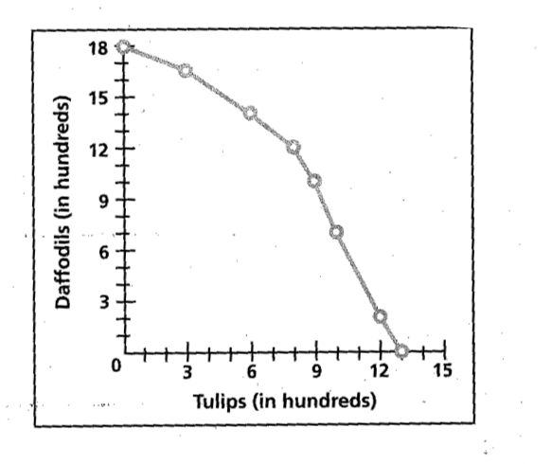
Put an A on the curve where the most efficient use of resources is illustrated by producing as many daffodils as tulips. How many of each are being grown?________________ (approx.)
Put a B to show 1500 daffodils being grown. What is the opportunity cost in tulips?_______________
Put a C to show 1200 tulips being grown. What is the opportunity cost in daffodils?_______________
Put a D to indicate a point of idle or unused or under used resources
Put an E to indicate a point of production that can’t be met due to not having access to more resources

Lesson 3
- How does specialization affect productivity?

- How do businesses and individuals participate in both factor and product markets?

- How does a cost-benefit analysis help make economic decisions?

- Why is economic growth important?
- Fill out the circular flow chart on the next page.

